**Green Society Public School**

**D-07**

**Ratnanagar-7, Sauraha, Chitwan**

**Second Terminal Examination-2082**

**Class: LKG Time: - 2 hrs. F.M.: 50**

**Sub: Social Science**

|  |
| --- |
| **Name: Roll No.: Sec.:** |
| **­­­­­­­­­­­­ ________________ ______________ OBT.MARKS:**  **INVIGILATOR EXAMINER** |

**1. Name the given pictures. (4)**

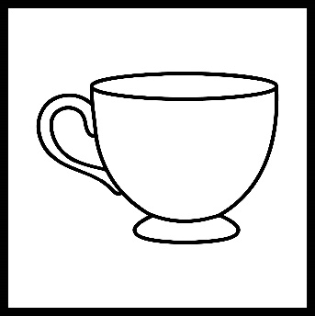

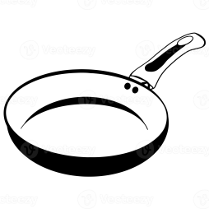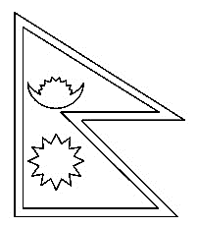

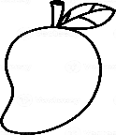**2. Count and write. (4)**

**=**

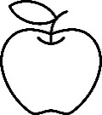

=

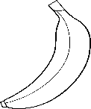

**=**

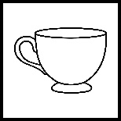

 **=**

**3 Circle the similar words. (5)**

Kettle = Kettle Kite

Fork = Flower Fork

Soap = Soap Shampoo

Mirror = Mat Mirror

Towel = Towel Table

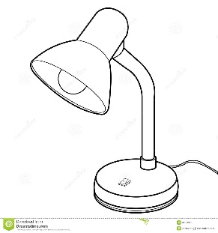**4. Tick (√) the correct words. (5)**

Comb Lamp

Cap Lip

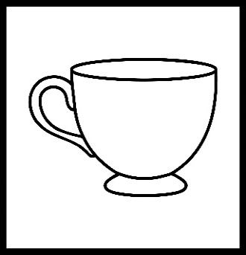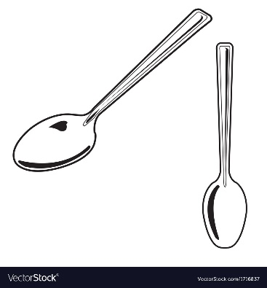

Cup Spoon

Car Sofa

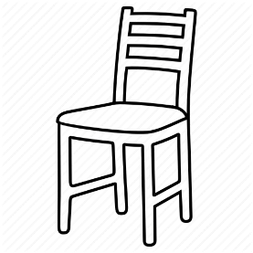

Chair

Colour

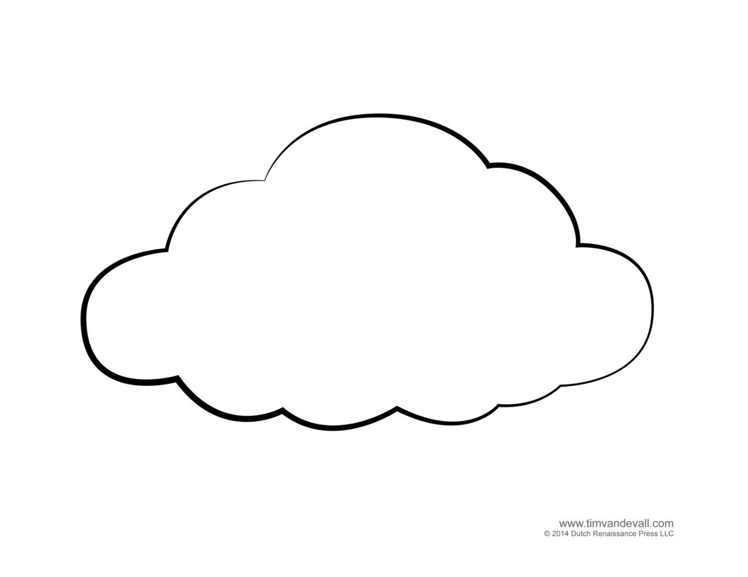**5. Name any 5 body parts. (5)**

**____________**

**_____________ _____________**

**____________ _____________**

**6. Write ‘G’ for good habits and ‘B’ for bad habits. (5)**

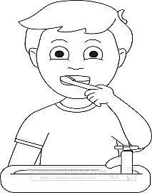

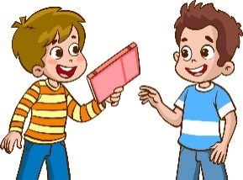

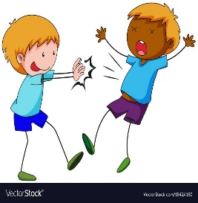

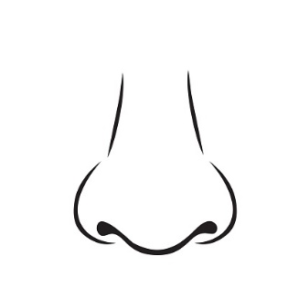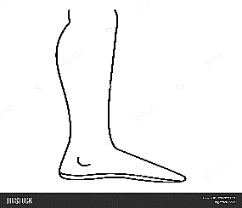**7. Look at the picture and circle the correct words. (5)**

Nose Leg

Mouth Foot

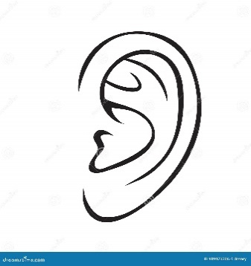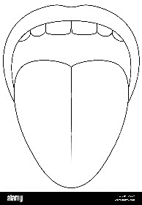

Tongue Ear

Teeth Eye

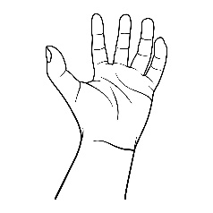 Hand

Leg

**8. Circle only vegetables.**  **(5)**

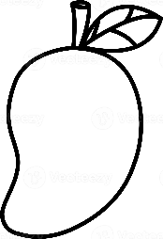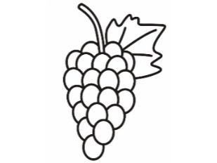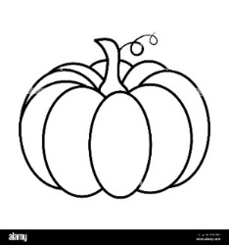

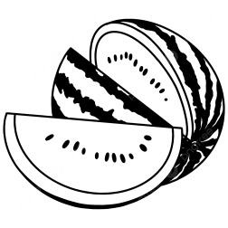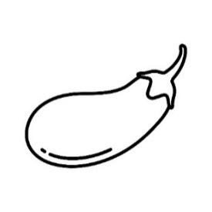

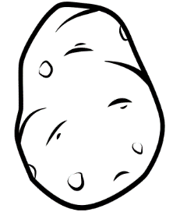

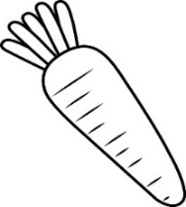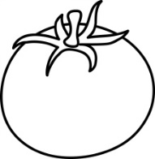

**9. Write ‘L’ for living things and ‘N’ for non-living things. (6)**

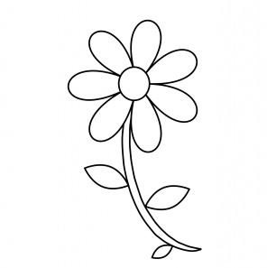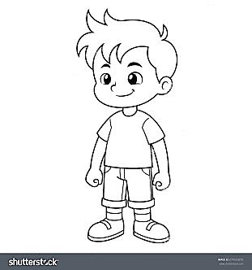

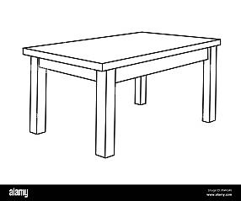

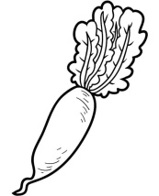**10. Match the correct pictures. (6)**

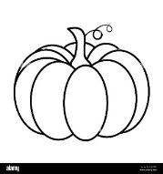Pumpkin

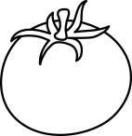 Tomato

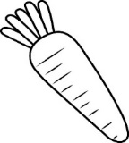 Radish

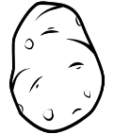 Potato

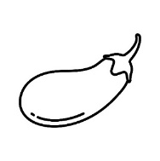 Brinjal

Carrot

**The End**